Guiding Questions
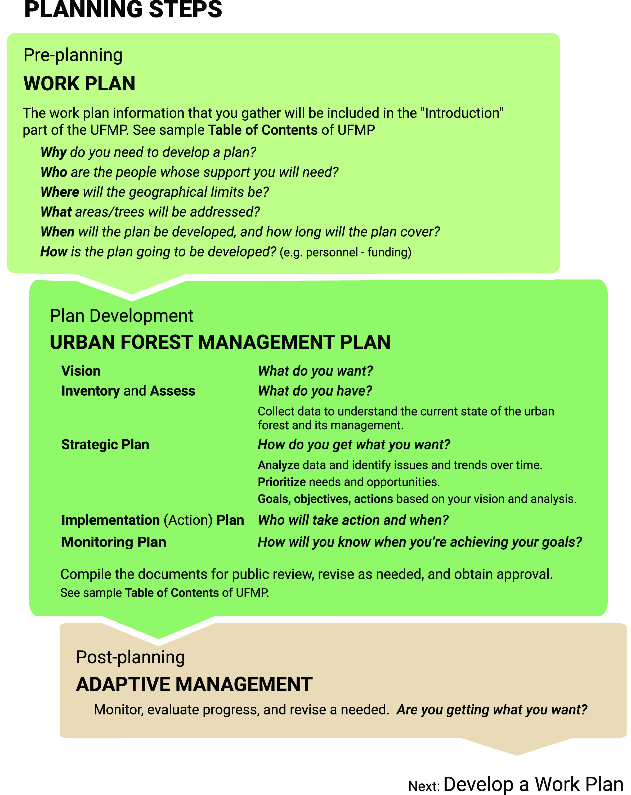

WORK PLAN QUESTIONS

Why?
Why do you need to develop a plan?

Who?
Who will be responsible for plan development?

Who will help with plan development?

Work Plan Task Table Example
 | Sample Task Descriptions | Target Date | Who
1 | Authorization and scoping  Begin Work Plan development
2 | Initial meeting(s) to gather input and assign responsibilities.
3 | Develop Vision Statement with input
4 | Begin Inventories and Assessments  Establish data collection parameters and protocols
5 | Data collections
6 | Strategic Planning: Data analysis and synthesis
7 | Data presentation and initial goal setting meeting/s
8 | Develop Goals, Objectives, Actions.
9 | Gain approval of the Strategic Plan
10 | Implementation Plan: Develop a matrix with who will complete the action and when.
11 | Monitoring Plan: establish monitoring protocols, matrix
12 | Compile draft plan
13 | In-house review of draft plan
14 | Public presentation of draft plan
15 | Edit draft, compile/format final draft
16 | Final plan approval
17 | Begin implementation
18 | Begin monitoring and Adaptive Management

Who are the key people and groups that are impacted?

Who are the people and groups whose support you will need?

Who might be good at helping to develop or review the plan?

Which stakeholder groups are likely to influence the success of the plan?

Are these people aware of urban forestry, community concerns, and the specific needs of the area to be planned? If not, how will you educate and engage them?

Where?
Where will the geographical limits be?

What area will the plan cover?

What?
What information is needed?

What portions of the urban forest will be addressed (scope)? Street, park, facility trees, etc.

Will you be planning for trees on private residential, commercial, or urban-agricultural lands? (Trees growing on private lands actually compose the majority of urban forests.)
Are you planning for publicly owned trees, such as street, facility, or park trees?
Are you planning for the entire urban forest: public and privately owned trees within an urban area including trees along streets and in yards, as well as stands of remnant forests?
Does your plan include open space trees in wildland-urban interface, in wildland parks, along waterways, wildlife corridors?
Example Scope Table
Check those of interest | What will be assessed? | Managed by (specify, e.g., city, residential, commercial, etc.) | Geographic limits  (specify, if applicable) | Other (specify)
 | Overall canopy cover | (All)
 | Street trees
 | Facility trees
 | Parking lot trees/Shading
 | Park trees
 | Heritage trees
 | Open space trees
 | Other: specify

When?
What is the timeframe (horizon) that the plan will address? What planning, management and monitoring horizons will be addressed—5, 20, 50 years? Note if different short-term and long-term intervals apply to different plan components.

How?
How is the plan going to be developed?
Personnel: In-house staff or consultants? How will the tasks be shared?
Funding?
NOTE: The information you develop in the Work Plan section will help in development of the Introduction to the UFMP.

URBAN FOREST MANAGEMENT PLAN
QUESTIONS
VISION
Begin with the end in mind.
—Steven Covey

What do you want the urban forest to look like as a result of the plan?

What is the community’s/organization’s vision for the urban forest?

Describe the urban forest itself and how it will be cared for and valued by the people who manage it. For example, if we achieve our goals, how will the area be different than it is now?

As you proceed through the urban forest management planning process you may decide to re-visit and change your initial vision statement to include updated findings.

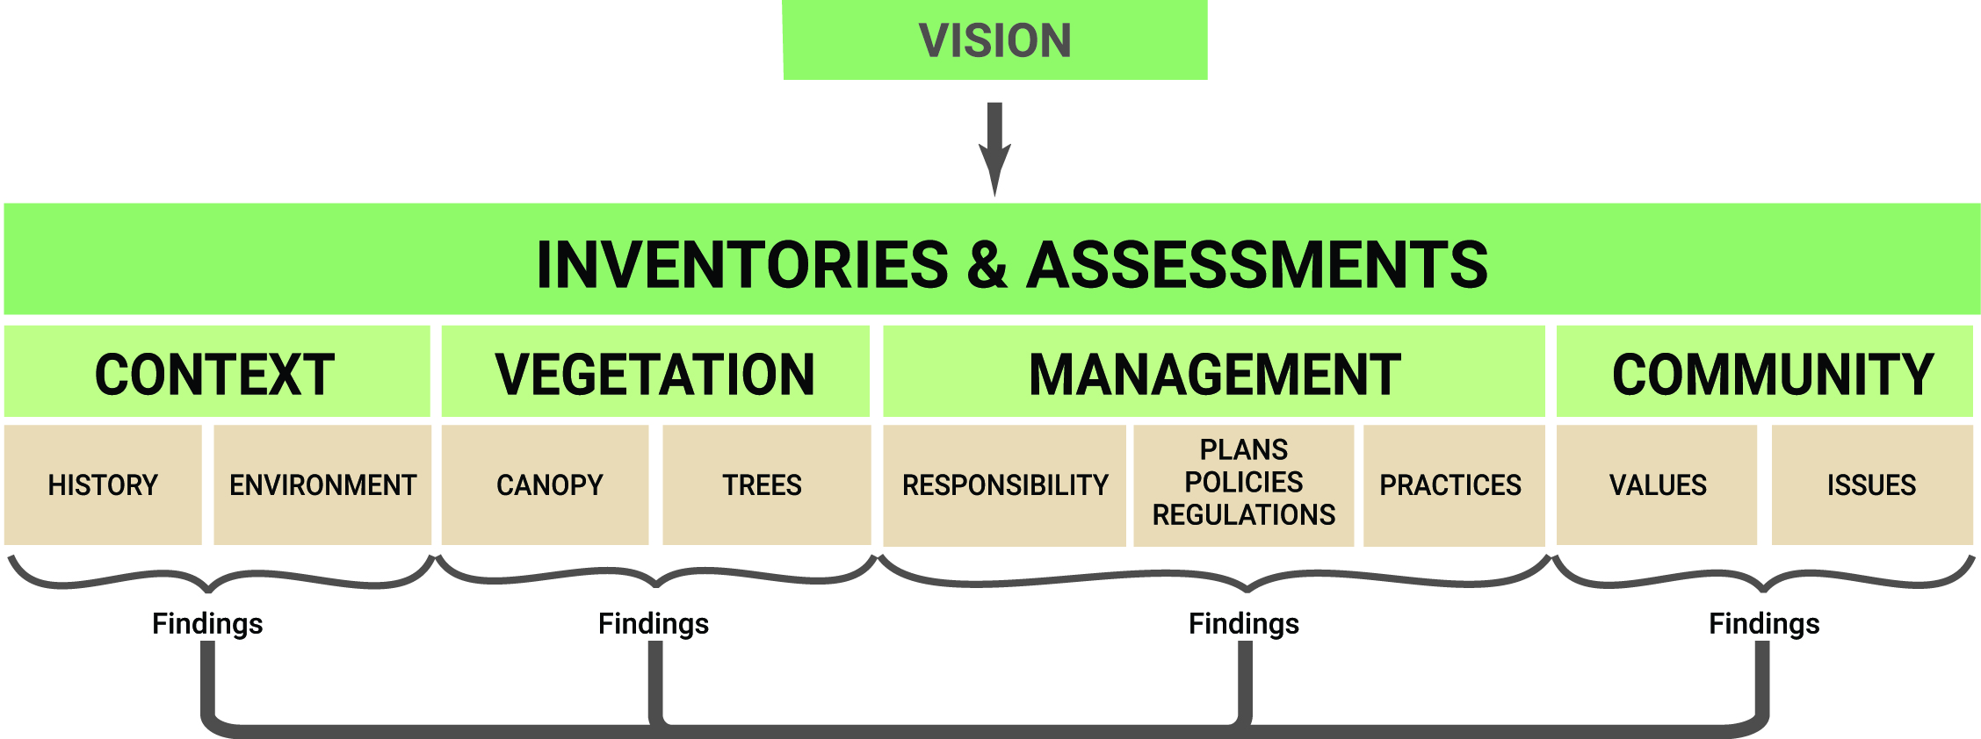

INVENTORIES and ASSESSMENTS
What do you have? Know where you came from to know where you are going.

CONTEXT

History and Land Use Changes
How has site history affected the development and composition of the current urban forest?

Based on how the urban forest has developed over time (e.g., overuse of certain species) what future management issues can be anticipated?
Is there a history of community stewardship of trees?

Are there trees of historical or cultural significance that are important to protect?

Environmental Assessments

What are the important environmental factors that affect tree management, selection and maintenance in the plan area?

How can these factors be taken into account in the urban forest plan?

For site-level plans, are there important conditions to consider? For example, are there mature trees that can be protected during construction and preserved for a residential or commercial development site?

Climate
What are the climate zones: USDA and/or Sunset’s Western Garden Book?
U.S. Department of Agriculture Plant Hardiness Zone Map http://www.usna.usda.gov/Hardzone/ushzmap.html
Sunset’s Western Garden Book climate zones http://www.sunset.com/garden/climate-zones

What is the average annual precipitation and extreme and average high and low temperatures?

Is supplemental water necessary for establishment and health of trees? If so, what is the source and quality of irrigation water?

Is it important to plant native or “waterwise” trees species?

Do these factors change in different portions of the plan area?

Soil Conditions
What are the general soil types and erosion potential? How could they limit urban forest development and management?

Fire Risk
Is wildfire a concern for the area being planned? If so, in what ways can it be addressed without creating erosion hazards and habitat degradation?

Invasive Species
Are invasive pests and weeds of concern for the area being planned? If so, assess how the invasive species can be reduced or eliminated to reduce negative impacts.

Species of Concern

Are species of concern dependent on trees/vegetation within the planning area? If so, what management considerations, studies, and procedures will be considered in the UFMP? For example, pruning and disturbance will be precluded from the habitat of sensitive species during mating and nesting seasons.

Other Include summaries of other relevant environmental concerns that relate to the planning site.

VEGETATION

Canopy Cover
Find the outermost canopy boundaries and measure. What percent of that area is covered by trees?
Compute the benefit of the existing canopy cover.

Can you define canopy cover targets for the planning area as a whole and/or for segments within the planning area (e.g., residential areas)?

How does current canopy cover compare to possible canopy cover targets?

Are canopy cover levels in the parts of the planning area at or near maximum sustainable levels? If so, should these levels be used to set targets?

What factors (environment/trees/management) are associated with the urban forest in areas that have maximum or optimal canopy cover levels?

Tree-Vegetation Inventory
What inventory method will be used?

List of Inventory Management Software
This list, compiled by the U.S. Forest Service, contains lists of commercial software and public domain program.
http://www.na.fs.fed.us/urban/inforesources/inventory/Tree%20Inventory%20Software%20List%20-%20%20January%202014.pdf

Template
 |  | Tree Inventory
Collector _________________
Date _________________
Tree ID | Genus species | DBH | Ht. Cl. | Hlth | Site Con. | Conflicts | Comments

DBH 1 = <10 in. 2 = 10-20 in. 3 = >20 in.
Ht. Class 1 = <15 ft. 2 = 15 - 30 ft. 3 = 30 - 45 ft. 4 = > 45 ft.
Health 1 = good 2 = fair 3 = poor 4 = dead
Site Cond. 1 = shrubs 2 = grass 3 = paving 4 = bare walls 5 = mulch
Conflicts 1 = pot. Overhead utility 2 = exi. Overhead utility
3 = building/other structure 4 = sidewalk/curb 5 = other

Urban Tree Considerations

Street Trees

What types of tree and site data should be assessed/analyzed?

Are necessary data available in an inventory or are surveys needed?

What are the most meaningful ways to stratify tree data: by species, size class/age, condition class, maintenance needs, planting situation?

It is practical or useful to divide street trees into geographic management zones? If management zones have been in use, how well do they work?
How do we identify/quantify empty planting spaces?

Is the long-term sustainability of street tree canopy at risk due to a lack of age and/or species diversity?

What is the frequency and severity of conflicts between street trees and other elements of infrastructure (e.g. curbs, sidewalks, overhead lines)?

Facility Trees

Which departments currently manage facility trees?

Are there maintenance / management issues that are unique to some or all facility trees in the plan area?

Should facility trees be handled separately from other groups of trees in the management plan?

Can we define management zones for facility trees based on planter size, location relative to buildings, or other factors?

Parking Lot Trees

What is the planting site size?

What is the number or percent of empty planting spaces?

What is the parking space to tree ratio?

What percent of parking spaces are shaded? Use shade categories (e.g., <10%, 10-50%, >50%) to show degree of shading in shaded spaces.

Park Trees

What maintenance and management issues are common in park sites?

Which parks need to be treated individually for planning purposes?

Can we create useful groupings of park sites based on location, year of construction, or other factors?

What roles do trees play in various park sites?

Heritage Trees

Are there “heritage” trees or trees of historical or cultural significance that are important to protect?

Which trees are affected by the permit process or design review?

What are the reasons for permit requests?

What heritage trees have been removed? Reason for removal?

What is the amount of mitigation for removed trees? e.g. money and/or trees planted.
Did mitigation trees survive?

Open Space Trees

Is the composition of existing native trees a factor to consider?

What is the overall health of forests/woodlands in our open space areas?

What changes have occurred in these stands?

What changes are likely to occur over time under current management practices?

How do current and projected uses of the open space and surrounding properties affect the management of the forests/woodlands?

Are there information gaps related to management of open space stands?

Are there other vegetative components that are important to assess?
Is conservation of existing native trees a factor to consider, such as along a waterway? What is or would have been the native vegetation/trees?

Are there interface issues between urban, agriculture and/or habitat lands, such as escaped exotic species or landscaping with invasive species?

MANAGEMENT

Responsibilities
How are activities of different entities coordinated and monitored?

Are the various entities that affect trees working with the same vision and toward the same end?

Are all units supporting the overall management goals through their activities?

Which entities regulate or affect segments of the urban forest? (e.g., tree committees, city councils, boards of supervisors, planning commissions, or land use committees)

Do these entities and tree managers take advantage of partnering with organizations and concerned citizens for the benefit of the urban forest?

Who educates the public about the urban forest and tree care regarding both private and public property?

Which entities perform activities that affect the urban forest? In relation to:
- Tree health
- Growing space
- Utility line clearance
- Damage to sidewalks and other hardscape due to tree roots
- Construction damage to tree roots
- Exotic species invading natural areas
- Fire hazards at the urban/wildland interface

Which departments have direct tree care responsibilities and what portions of the urban forest do they manage?

Are the assigned roles and responsibilities providing for efficient and effective management of the urban forest? Evaluate the pros and cons of shifting responsibilities and in-house vs. contracted work.

In what ways, if any, could efficiency be improved? (Combining units, sharing equipment, or partnering with other departments or organizations)

Assess for each unit/department that has direct tree care responsibilities:
Are staff, training, and budget adequate to provide for tree care needs?

Does retention rate affect program capabilities?

What inventory and work scheduling system is used? How well does it work?

Example of Summary of Management Responsibilities

Activity | Activity subclass | Arborist | Public Works | Parks | Planning | Other:  specify
Planting | New sites
 | Replacement plantings
Pruning | Scheduled
 | Storm/emergency
 | Utility clearance
 | Street/equipment clearance
Tree removal | Hazard trees
 | Clearance (for flood control, fire safety, etc.)
Root system work | Sidewalk/curb repair and replacement
 | Excavation for utilities
 | Construction
Permitting | Planting
 | Pruning
 | Removal
Outreach/ education | Property owners/public
 | Contractors

Plans, Policies, Regulations

How will the UFMP be related to other plans and regulations?

Is there an urban forestry or green infrastructure component in other plans?

Do any plans need to be amended/updated to reference the UFMP or to ensure compatibility?

Plans

Are there urban forestry components in other plans? Which documents (city codes, general plan, specific plans, and design and landscaping guidelines) include tree-related guidelines and regulations?

Are notifications, design consultation, and oversight adequate to protect trees from harm?

What will be the relationship of the UFMP to other planning documents?

Policies

Are there tree-related policies? If so, are they current?

Are policies followed?

Regulations

Are there any regulatory measures pertaining to parts of the urban forest?

Are local tree trimmers required to have “Wildlife Aware” type training to prevent bird nest disturbance during nesting season?

Which areas or classes of trees are subject to regulation?

How would regulations impact management?

Are there tree care ordinances?

What is the impact of existing regulations on targeted tree populations (e.g., street trees, heritage trees?)

To what degree are ordinances/regulations enforced? Possible measurements might include number of permits, violations, citations issued, and penalties or fines collected.

Do ordinances need evaluation/revision?

Do state or federal regulations (e.g., California’s AB32, The Global Warming Solutions Act) need consideration in regard to management of the urban forest?

Example Summary of Plans, Policies, and Regulations already in place

Tool | Street trees | Park trees | Facility trees | Heritage trees | Parking lot trees | Other:  specify
Ordinance
General plan
Specific plans
Improvement standards
Specifications - planting
Specifications - pruning
Hazard program
Street tree master plan
Approved planting list

Refer to Guidelines for Developing and Evaluating Tree Ordinances

Overall, does the regulatory framework need to be expanded or updated?

Are guidelines consistent throughout all documents?

Do any of documents need to be amended or updated to ensure compatibility and reference the UFMP?

Practices
Are best practices employed for the sustainable management of the urban forest?

Are standards and practices up to date based on the best available information and research?

Is there adequate species and age diversity within the urban forest?

Are declining trees evaluated for risk? Are hazards removed?

How are trees maintained, and what is the duration of the maintenance cycle?

When each tree has reached the end of its useful lifespan, is biomass reused and at its “highest and best use”?

ANSI A300 standards and corresponding best management practices are the generally accepted industry standards.
What management actions would be needed to reach target canopy levels?

Conduct an audit of past tree care practices to determine which have been successful and which are problematic. For each unit that has direct tree care responsibilities, ask:
How are decisions made relative to tree selection, placement, maintenance, and removal?

Are practices and standards used, including inspection, maintenance, and notification?

Are you able to adopt/update standards available from government (e.g., CAL FIRE), industry (e.g., ANSI), and professional (e.g., International Society of Arboriculture) sources? Would you need to modify or append these standards to account for local conditions?

Is there adequate equipment? Consider the condition, maintenance, and expected service life?

Are most of the pruning and removals on a scheduled or unscheduled basis, such as response to calls or weather events?

Is there an adequate budget and funding to achieve sustainable urban forest management?

COMMUNITY

Who are the key people and groups that are impacted?

Who are the people and groups whose support you will need?

Who might be good at helping to develop or review the plan?

Which stakeholder groups are likely to influence the success of the plan? Are these people aware of urban forestry, community concerns, and the specific needs of the area to be planned?

Values
Design a survey for your stakeholders.
Which questions will best assess your stakeholders’ values and help identify their issues?

Summarize your stakeholders’ values about the urban forest?

Are awareness and education needed regarding urban forest benefits, management, and tree care?
If so, how will you educate and engage stakeholders?

Is there a stewardship ethic in the community for urban forestry?

Issues
Summarize the specific issues that are relevant to your plan to include in the stakeholder attitude assessment.

Summarize Inventories and Assessments for the Status of the Urban Forest section of the UFMP.

STRATEGIC PLAN
The strategic planning portion of the Urban Forest Management Plan includes the development of goals, objectives, and actions that will lead to the achievement of your vision for the future of the urban forest. The strategic planning process begins with the analysis of the data collected from Inventories and Assessments.

ANALYZE
As you analyze the data that you collected from Inventories and Assessments, try to determine how the urban forest arrived at its current state. For instance, why is canopy cover decreasing?

Issues and Trends
What issues and trends have been identified relative to:
- Tree and vegetation resources
- Management
- Community?

What practices would need to be continued or changed to maintain or expand the existing urban forest?

What management actions would be needed to reach target canopy levels?

Is awareness and education needed regarding urban forest benefits, management, and tree care?

GOALS
Develop broad goals that address the needs you have identified. What do you want? What would be the elements of a highly successful UFMP?
Review and revise your community’s vision for the urban forest.
How could you bring your vision to reality? What would have to happen in terms of
- Tree resources
- Management
- Community?

OBJECTIVES
Objectives provide more specificity by breaking goals into the components.
What are your objectives for each goal?

ACTIONS
What are your steps of action for each objective?

Tools

What tools will you need to complete each action?
Compare the feasibility, cost, and effectiveness of tools alternative actions.

IMPLEMENTATION (Action) PLAN

Develop an implementation plan or matrix that spells out:
- Priority ranking
- Time schedule
- Personnel responsible for administering and carrying out the action
- Funding sources
- Specific budget on an annual or multi-year basis and funding source(s)

Review Priorities

What are the highest priority actions? Rank actions according to priority.

Which actions need to occur in a specific sequence?

Establish Time Frames and Timelines

Should goals, objectives, and/or actions be phased or organized by time frame, e.g.: within one, five, or ten years?

Assign Responsibilities

Identify responsible parties in the Implementation Plan

Funding

Have you investigated all possible sources of funding for the plan?
Identify and list funding sources/levels for action items.

Budget Development

How will you develop and present the budget?

Upon which scenario or scenarios (varying levels of service) should the budget be based?

5 Year Tree Care Budget Projections
 |  |  | YR 1 | YR1 | YR2 | YR2` | YR3 | YR3 | YR4 | YR4 | YR5 | YR5 | 5 YR TOTAL
Activity | Diameter class | Cost/  tree | # of trees | Total cost | # of trees | Total cost | # of trees | Total cost | # of trees | Total cost | # of trees | Total cost
Specify  activity | 1-6”
 | 7-12”
 | 13-18”
 | 19-24”
 | 25-30”
 | 31-36”
 | more than 36”
Activity totals

Estimated Costs for Five-Year Urban Forest Management Plan |  |  | Year 1 |  | Year 2 |  | Year 3 |  | Year 4 |  | Year 5 |  | 5-yr cost
Activity | Dia. Class | Cost/  tree ($) | # of trees | Total cost | # of trees | Total cost | # of trees | Total cost | # of trees | Total cost | # of trees | Total cost
Tree removals | 1-6”
 | 7-12”
 | 13-18”
 | 19-24”
 | 25-30”
 | 31-36”
 | Over 36”
Activity totals
Stump removals | 1-6”
 | 7-12”
 | 13-18”
 | 19-24”
 | 25-30”
 | 31-36”
 | Over 36”
Activity totals
Inter-mediate priority pruning | 1-6”
 | 7-12”
 | 13-18”
 | 19-24”
 | 25-30”
 | 31-36”
 | Over 36”
Activity totals
High priority pruning | 1-6”
 | 7-12”
 | 13-18”
 | 19-24”
 | 25-30”
 | 31-36”
 | Over 36”
Activity totals
Routine pruning | 1-6”
 | 7-12”

Budget Template
 |  |  | YR 1 | YR 1 | YR 2 | YR 2` | YR 3 | YR 3 | YR 4 | YR 4 | YR 5 | YR 5 | 5 YR TOTAL
Activity | Subactivity | Cost/tree $ | # of trees | Total cost | # of trees | Total cost | # of trees | Total cost | # of trees | Total cost | # of trees | Total cost
Tree planting | Site prep
 | Tree purchase
 | Planting
Activity totals
New tree mainten-ance | Training/pru-ning
 | Mulching
 | Watering
Other mainten-ance
Activity totals
Grand totals per year

MONITORING PLAN

The goal of the monitoring plan is to provide the data needed to understand what is happening, why it is happening, and how specific management adjustments will change the outcome. By monitoring the urban forest system, information can be gathered to make these adjustments (adaptive management).

What?
Which trees or program activities need to be monitored?

What additional factors need to be monitored?

Will you be monitoring the entire population or a sample?

When?
Will data be collected continuously (e.g., inventory updated by work records) or at specific intervals?

Do some data need to be collected in a specific season or time of year?

How frequently will you do data summary and analysis?

When to collect and analyze the data?

Who?
Who will collect, analyze, and use the information?

How much staff, consultant, and volunteer time will be needed?

How?
How will you gather and analyze the monitoring data?

Are you already collecting the data you need (e.g., in your tree inventory)?

Will you need to initiate additional sampling or recordkeeping?

How and where will you store the data (e.g., existing GIS, new databases)?

Where? Define the overall scope of your monitoring activities.

FINAL STEPS

Compile the Plan

Sample UFMP Table of Contents

Cover: Title (Name of the jurisdiction) Urban Forest Management Plan

Table of Contents

Introductory Information

Dates covered by plan

Prepared for:

Prepared by:

Plan approval date and/or date of final draft

Approved by:

Acknowledgements

Mission statement
Executive summary

Vision statement

Introduction (Information summarized from the Work Plan)

Status of the Urban Forest (Information summarized from Inventories and Assessments)
Context
History and Land Use Changes
Environmental
Vegetation
Canopy Cover
Tree Inventory
Management
Responsibilities
Plans, Policies, Regulations
Management Practices
Community
Values and Issues

Strategic Plan

Issues and Trends

Needs

Tree

Management

Community

Goals, Objective, Actions

Implementation (Action) Plan

Monitoring Plan

Appendices

Technical guides and standards; Assessment methods; Planning documents and policies;

Ordinances; Resources; Other

Plan Review
Stakeholders are invited to review the draft plan, and revisions are made as needed.

Plan Approval and Adoption
The final version will need to be approved by the entity that approves budget expenditures.

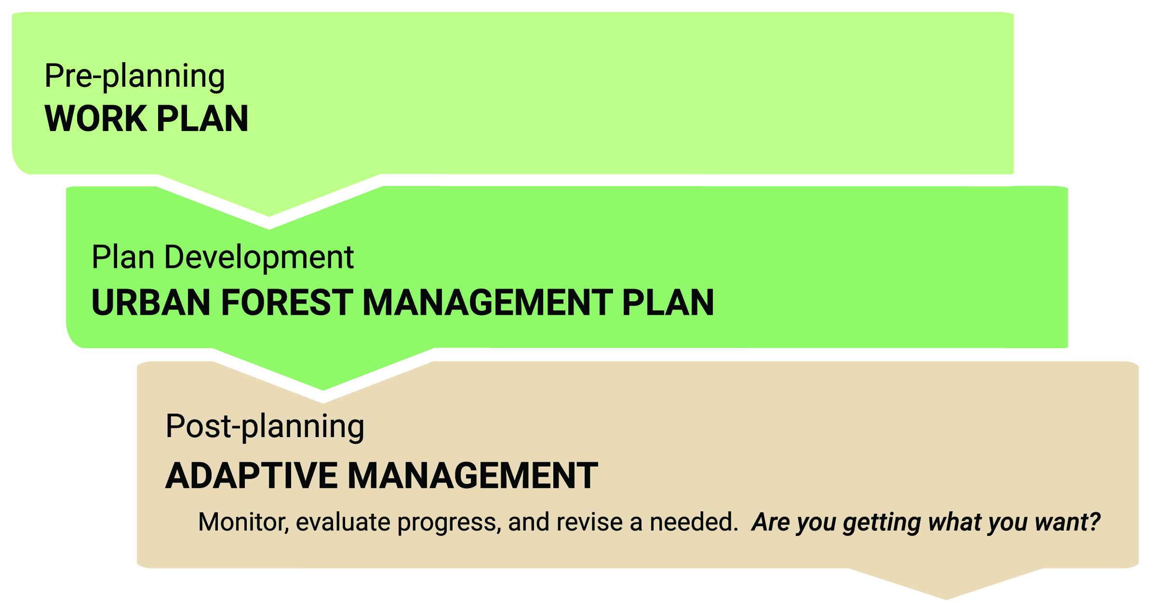

ADAPTIVE MANAGEMENT
Are you getting want you want?

